**Assignment 5**

**The Environment of Framework**

There is an effective tool called framework to create, manage and organize structure, event planning and business regarding architecture. This report will discuss two frameworks which are ITIL and COBIT framework. We will explore both frameworks and will map ITIL framework on COBIT framework to check which practices overlap in both of these framework when applied to an organization.

**Linkage between ITIL and COBIT**

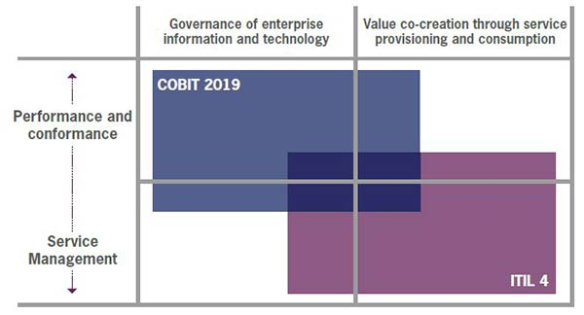

Both of these frameworks match and complement each other at some point but both have a different and unique initial point. The figure above shows how both initiate from value vs governance point of view. But their practicalities are different as ITIL enumerates management of service and COBIT helps in maintaining efficiency and the execution performance.

Now let us study of these frameworks and their benefits in details below:

**ITIL**

This framework gives a shape to the to management of service which are ITSM practices in the broader area which also covers experience of a customer and digital changing. It motivates and supports new modes of work environments and methods like for example Agile, Lean etc. this framework also provides assistance in managing services and to balance the upcoming potential and capabilities of the current technology which is modernizing day by day. This framework is created to make sure that there is flexibility, coordination work environments for better and efficient governance and handling of all services of IT. ITIL is designed around an SVS (Service value system) which is a concept of high level and it shows how enables services of IT are facilitated by components of an organization.

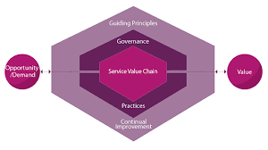

**COBIT**

This framework is adopted globally for organizations that have roots in control and audit of Information Technology (IT). It is defined for a specific audience which are stakeholders from inside, management in executive department, managers of IT, partners which are doing business with each other, vendors and these two are eternal stakeholders. COBIT is based on the COBIT Core which is in combination with the generic version of management objectives and governance which are set up in a domain of 5 keys in the model of reference.

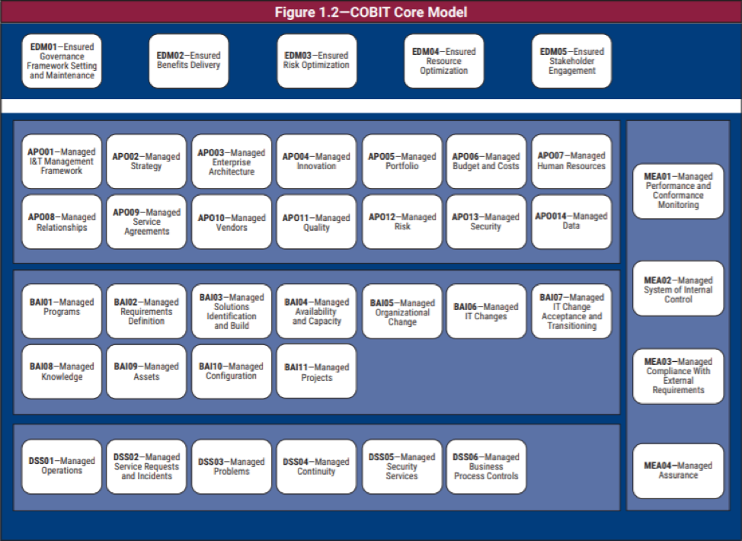

**Mapping ITIL to COBIT**

|  |  |  |
| --- | --- | --- |
| **General Management** | **ITIL** | **COBIT** |
| Management of Architecture | APO03 (Management of Enterprise Architecture) |
| Management of Information and Security | APO13 (Security Management)  DSS05 (Security Services Management) |
| Management of Knowledge | BAI08 (Managing Knowledge) |
| Consecutive Improvement | APO11 (Quality Management)  Performance Management  MEAO1 (Keeping Track) |
| Management in Organizational Change  Management of Portfolio | APO05 (Handling Portfolio)  BAI05 (Handling Change in Organization) |
| Checking and Then Report | EDM05 (Stakeholder involvement surety) |
| Management of Relations | APO08 (Maintaining Relationships) |
| Risk Handling | EDM03 (Ensuring Risk Control)  APO12 (Risk Handling) |
| Management in Strategy | APO02 (Strategy Managing) |
| Management of Supplier | APO10 (Supplier Managing) |
| Management of Employees and Talent | APO07 (HR Management) |
| Management of Project | BAI01 (Program Management)  BAI11 (Project Managing) |

|  |  |  |
| --- | --- | --- |
| **Service Management** | **ITIL** | **COBIT** |
| Management of Availability | BAI04 (Availability Handling) |
| Analysis of a Business | BAI02 (Management of requirements) |
| Management of Efficiency and Effectiveness | BAI04 (Availability Handling) |
| Enabling Change | BAI06 (Handling Changes in IT) |
| Management of Incident | DSS02 (Request regarding service management) |
| Management of assets of IT | BAI09 (Asset handling) |
| Management in Security and Event | DSS01 (Operation Handling) |
| Management of Problem | DSS03 (Problem Handling) |
| Management of Release | BAI07 (Management of Transformation and change in IT change) |
| Management of Service Catalogue | APO09 (Agreements regarding service management) |
| Management of Configuration of Service | BAI10 (Configuration handling) |
| Management of Continuity in Service | DSS04 (Continuity handling) |
| Check over Design | BAI03 (Handling Builds and Recognition of results) |
| Desk for service | DSS02 (Request regarding service management) |
| Managing Request regarding service | DSS02 (Request regarding service management) |
| Testing for validation of service | BAI07 (Management of Transformation and change in IT change) |

|  |  |  |
| --- | --- | --- |
| **Technical Management** | **ITIL** | **COBIT** |
| Managing Deployment | BAI07 (Management of Transformation and change in IT change) |
| Management of platform and structure | BAI03 (Handling Builds and Recognition of results) |
| Management of SD (Software Development) | BAI03 (Handling Builds and Recognition of results) |

**Design and Implementation of The Frameworks**

If an organization really wants to know the real value of the stakeholders, then it must understand the balance and should have enough knowledge regarding the conformance and performance. In this context, performance means that the organization must have the confidence and ability to run things along with retaining the value of consumer by providing a mechanism of control for the organization. The organization can be efficient enough to deliver excellent services but if does not have a sufficient and proper control and also security which is needed as the requirement by the industry, then you have failed as an organization.

These frameworks come in hand. As, COBIT has a distinguishable perspective regarding management and governance of IT and ITIL goal is to deliver services. COBIT can help in security, protection and control and ITIL can help in service performance. That is why, we can not pick one and have to pick both frameworks in order for an organization to have a better structure.

The design factors for COBIT are given in the figure below:

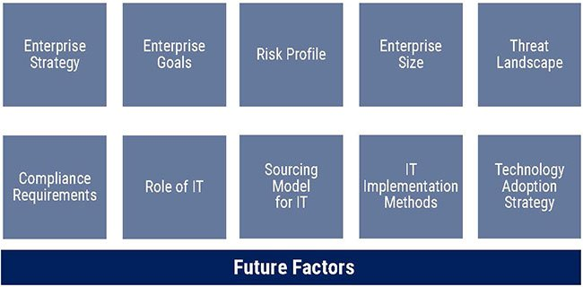

First of all, the organization needs to clear out which aspects they need for the design factor then these specific factors will be selected from the COBIT design factor to recognize which goals of governance and management are more related to the organizational objectives and goals. Every governance and management is somehow is a part of a COBIT process and it will help the organization to identify which practices of the ITIL are in need of a specific level of control if it wants to manage and retain Service value system.

COBIT has an implementation model in the process which is quite similar to the continual improvement model of ITIL and it has seven phases in it. Both COBIT implementation model and ITIL continual Improvement model is given below in figure 1 and figure 2 respectively:

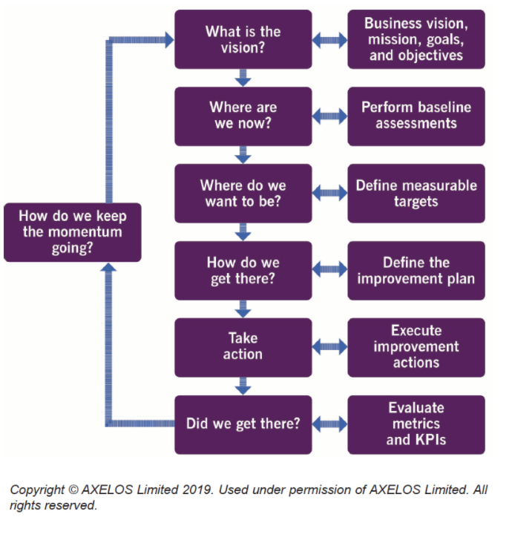

**FIGURE 1: ITIL Continual Improvement Model**

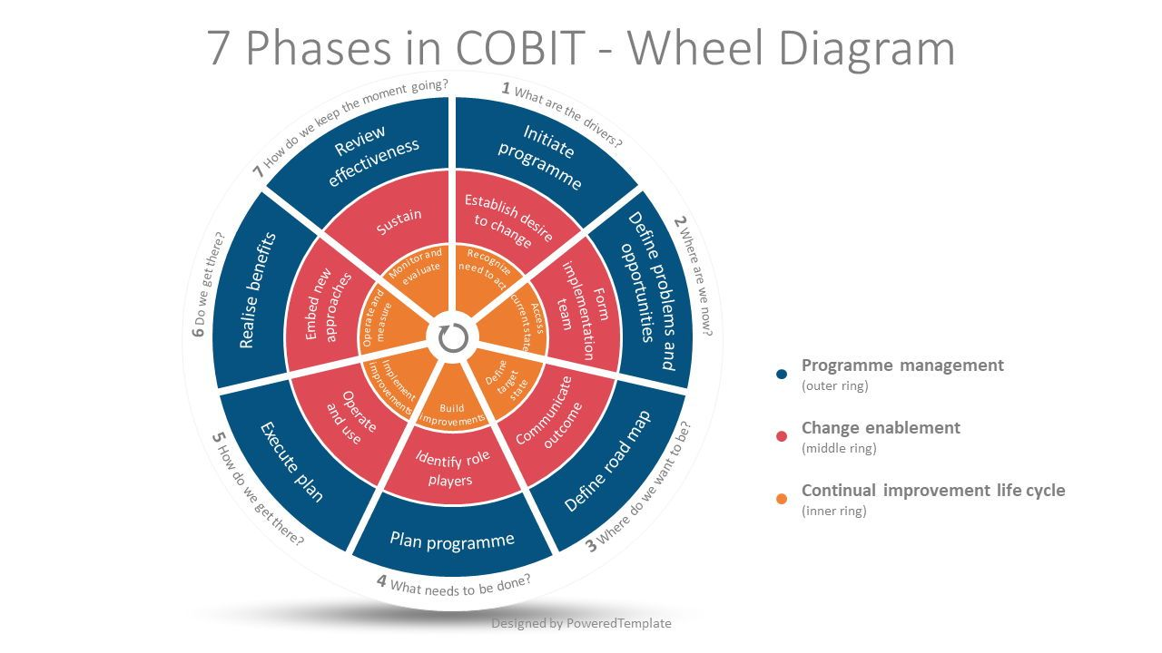

**FIGURE 2: COBIT Implementation Model**

The most inner circlepart of the implantation model is known as the continual life cycle. The purpose of this part if to coincide efforts in making improvements in every phase of the life cycle. Both of these models given above have different purpose. However, these models can be glued and used together to have a consistent betterment in any situation and kind of implementation.

Given below is the planning and evaluation model of ITIL:

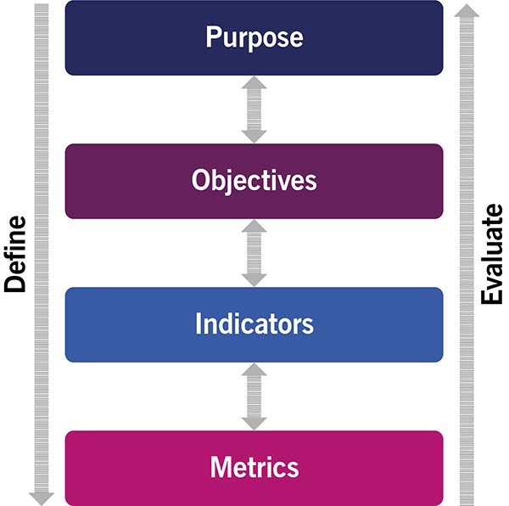

This model is aligned with the COBIT cascade model. As an organization is able to define its objectives, goals then they can define those objectives in the manner of COBIT goals cascade. In future, these objectives will eventually improve the organization’s strategy or helps the organization at some level. The COBIT goals cascade model is given below:

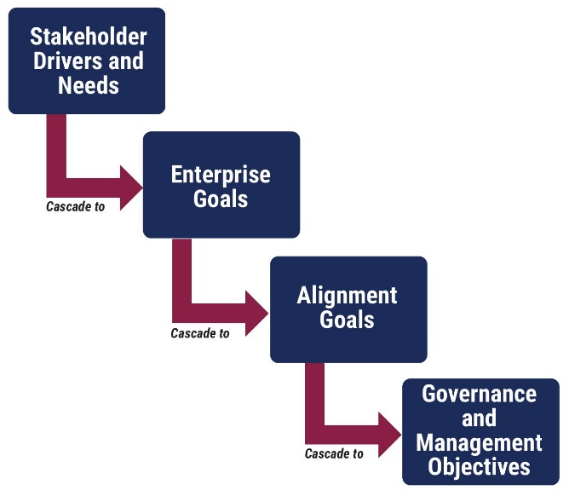

In the goals cascade model of COBIT, the needs of stakeholder can be mapped easily to the goals of the enterprise. There are total of 13 goals of enterprise which are managed in the manner hierarchy like financial, customer, growth etc. these goals of enterprise are thus aligned with the level of relationships with the goals that are aligned.

**Conclusion:**

By looking at the above implantation and design method of frameworks, we can see that a single framework can not fulfil needs of an organization. Thus, ITIL and COBIT are aligned and integrated together to influence and support the organizational needs.